**JIRA SOFTWARE INSTRUCTIONS  
*for the*  
*Technical Publications Department***

TABLE OF CONTENTS

1. ACRONYMS & DEFINITIONS 4

2. EXAMPLES OF ISSUE TYPES 4

3. SWIMLANES (Column Names) 5

4. IMPORTANT STEPS IN JIRA 8

4.1. How to Log in to Jira 8

4.2. The Three Main Steps Performed in Jira 11

4.3. How to View Your Assignments 11

5. INSTRUCTIONS FOR WRITER & TASK LEAD 12

5.1. Create New Milestone (Epic) 12

5.2. Create New TO/Pub# (Story) 12

5.3. Create ‘Text’ Sub-Task 13

5.4. Create ‘Illus’ Sub-Task 13

5.5. Illus Request Ready for Illustrator 13

5.6. Writer’s Copy Ready to Create Text Files 14

5.7. Text Files Complete 14

5.8. Illus Complete, Ready for Writer to Combine Files 14

5.9. TW Review Complete, Illus Corrections Needed 15

5.10. TW Review Complete, Text Corrections Needed (no illus corrections) 15

5.11. Illus Completed TW’s Corrections, Ready for TW Review 16

5.12. Combined File Ready for Engineer Review 16

5.13. Engineer Review Complete, No Redlines 16

5.14. Engineer Review Complete, Writer to Integrate Redlines 17

5.15. Engineer Corrections Ready for Illustrator 17

5.16. Illus Completes Engineer’s Corrections, Ready for TW to Recombine and Review 18

5.17. Combined File Ready for QA/LW Review 18

5.18. QA/LW Illus Corrections Complete, Ready for Writer to Recombine for QA/LW Review 18

6. INSTRUCTIONS FOR ILLUSTRATOR 20

6.1. Illus Request Ready to Work 20

6.2. Illus Request Files Complete, Ready for TW Review 23

6.3. Illustrator Completes TW’s Corrections, Ready for TW Review 25

6.4. Illustrator Completes Engineer’s Corrections, Ready for TW to Recombine & Review 26

6.5. QA/LW Review Complete, Ready for Illus Corrections 26

6.6. QA/LW Corrections Completed by Illus, Ready for TW to Recombine for QA/LW Review 26

7. INSTRUCTIONS FOR QA/LW 27

7.1. Combined File Ready for QA/LW Review 27

7.2. Combined File Needs QA/LW Illus and/or Text Corrections 29

7.3. QA/LW Review Approved (no corrections) 31

8. TROUBLESHOOTING 31

8.1. Accidently Moved Subtask/Card to Wrong Swimlane 31

9. FILE NAMING CONVENTIONS (for Writers and QA) 32

9.1. Writers 32

9.2. QA Personnel 33

LIST OF FIGURES

Figure 1: Screenshot of Swimlanes, TO/Pub# Rows, and Subtask Cards 5

Figure 2: Jira Workflow (Flow of Projects, Epics, and Stories) 6

Figure 3: Jira Workflow (Flow of Subtasks) 7

Figure 4: How to Create Jira Bookmark 8

Figure 5: How to View Specific Project 9

Figure 6: How to View Project’s Kanban Board 9

Figure 7: Kanban Board – No Filter Selected 10

Figure 8: Kanban Board – IPR (Epic) Filter Applied 10

Figure 9: How to View Specific Project 20

Figure 10: How to View Project’s Kanban Board 20

Figure 11: How to View Only Your Assignments 21

Figure 12: How to View Subtasks/Cards in Swimlanes 21

Figure 13: How to Fill In the Description for a Card/Subtask 22

Figure 14: How to Drag a Subtask/Card to a Different Swimlane 23

Figure 15: How to Change Assignee for Card/Subtask 24

Figure 16: How to View TO/Pub# Row 25

Figure 17: How to Select Correct Project 27

Figure 18: How to View a Project’s Kanban Board 27

Figure 19: How to View Only Your Issues 28

Figure 20: How to View Subtask/Card Under Certain Swimlane 28

Figure 21: How to Drag & Drop Card from Swimlane to Swimlane 29

Figure 22: How to Add an Entry to the Description for Subtask/Card 29

Figure 23: How to Change Assignee for a Subtask/Card 30

Figure 24: How to Accept the Selected Assignee for a Subtask/Card 30

1. ACRONYMS & DEFINITIONS

|  |  |
| --- | --- |
| **Project** | Program/Contract Name in Jira |
| **Issue** | Any task created in Jira under a Project, such as an Epic (Delivery Milestone), Story (TO/Pub#), Sub-Task, etc. Each issue has a unique “issue key” assigned to it. The key consists of an abbreviated version of the Project Name and ends with a sequential number. |
| **Epic** | Delivery Milestone in Jira (e.g., IPR#1, 80% IPR, Verification, Final, C-Redlines, E-Updates, etc.) |
| **E-Updates** | The Epic that stands for ETIMS-Update. When an update is needed on a certain TechPub. |
| **C-Redlines** | The Epic that stands for Customer Redlines. When corrections are needed based on customer comments. |
| **Story** | Individual TO#/Publication# in Jira |
| **Tasks/Subtasks** | A task in Jira that is part of a Story (TO/Pub). |
| **Reporter** | The person that creates the Jira Issue |
| **Assignee** | The person assigned to work on the Jira Issue |
| **TL** | Task Lead |
| **LW** | Lead Writer |
| **TW** | Technical Writer |
| **ENG** | Engineer/Engineering |
| **ILLUS** | Illustrator/Illustrations |
| **CXS** | Corrections |
| **WC** | Writer’s Copy |

1. EXAMPLES OF ISSUE TYPES

Each **Epic** refers to the different milestones for a contract. They are named according to what the customer refers to as a delivery (e.g., “IPR #1”, “40% IPR”, “Verification”, etc.).

|  |  |
| --- | --- |
| **A-10 HRDS (OA06)** | *Project* |
| IPR #1 | *Epic* |
| 1A-10C-2-5 | *Story* |
| 1A-10C-2-6 | *Story* |
| IPR #2 | *Epic* |
| 1A-10C-2-5 | *Story* |

Each TO/Pub is referred to as a **Story**. A regular TO# will be for our main process. If you see “E-Update” or “C-Redlines” beside the TO#, you know that it is either for an ETIMS Update or it has Customer Redlines.

|  |  |
| --- | --- |
| **T-6 CSR (N710)** | *Project* |
| 40% IPR | *Epic* |
| 1T-6ABD-2-1 | *Story* |
| E-Update | *Epic* |
| 1T-6ABD-2-1 (E-Update) | *Story* |
| C-Redlines | *Epic* |
| 1T-6ABD-2-1 (C-Redlines) | *Story* |

1. SWIMLANES (Column Names)

There are 16 Swimlanes (Column Headings) that a subtask can reside in. The names of the swimlanes, and a short description of when a subtask would be moved into that swimlane, is defined below:

|  |  |  |
| --- | --- | --- |
| **PERSON** | **SWIMLANE** | **DESCRIPTION** |
| N/A | **IN PROGRESS** | *AN Epic or Story or Task is waiting to be created and assigned a TW.* |
| TW | **CREATE WC** | *TW gathers source data and engineering drawings to create W/C.* |
| TW | **CREATE ILLUS REQ** | *TW creates an Illus Request from the WC and sends to an Illustrator.* |
| Illus | **CREATE ILLUS FILES** | *TW sends Illustrator the Illus Request to create illus files.* |
| Comp | **CREATE TEXT FILES** | *TW sends Comp the W/C to create text files, import illus, and create PDF files.* |
| TW | **TW REVIEW** | *Comp sends TW the PDF to review <****OR****> the TW CXS need reviewing.* |
| Illus | **ILLUS CXS FROM TW** | *TW sends Illustrator the TW CXS (unless no illus CXS are needed).* |
| Comp | **COMP CXS FROM TW** | *TW (or Illustrator) sends Comp the TW CXS to integrate.* |
| Eng | **ENG REVIEW (if req)** | *TW sends ENG the PDF to review (if required).* |
| TW | **TW REVIEWS ENG REDLINES (if req)** | *ENG sends TW Engineering Redlines to review and integrate (if required).* |
| Illus | **ILLUS CXS FROM ENG (if req)** | *TW sends Illustrator the Engineering CXS (if required).* |
| Comp | **COMP CXS FROM ENG (if req)** | *TW (or Illustrator) sends Comp the Engineering CXS (if required).* |
| QA | **QA REVIEW** | *Comp sends QA the corrected PDF <****OR****> the QA CXS need reviewing.* |
| Illus | **ILLUS CXS FROM QA** | *QA sends Illustrator the QA CXS (unless no illus CXS needed).* |
| Comp | **COMP CXS FROM QA** | *TW (or Illustrator) sends Comp the QA/LW CXS.* |
| TL | **TL REVIEW** | *Comp or QA sends the TL the final PDF <****OR****> the TL CXS need reviewing.* |
| Illus | **ILLUS CXS FROM TL** | *TL sends Illustrator the TL CXS (unless no illus CXS needed).* |
| Comp | **COMP CXS FROM TL** | *TL (or Illustrator) sends Comp the TL CXS.* |
| CM | **DONE** | *The approved TL PDF is logged as completed.* |

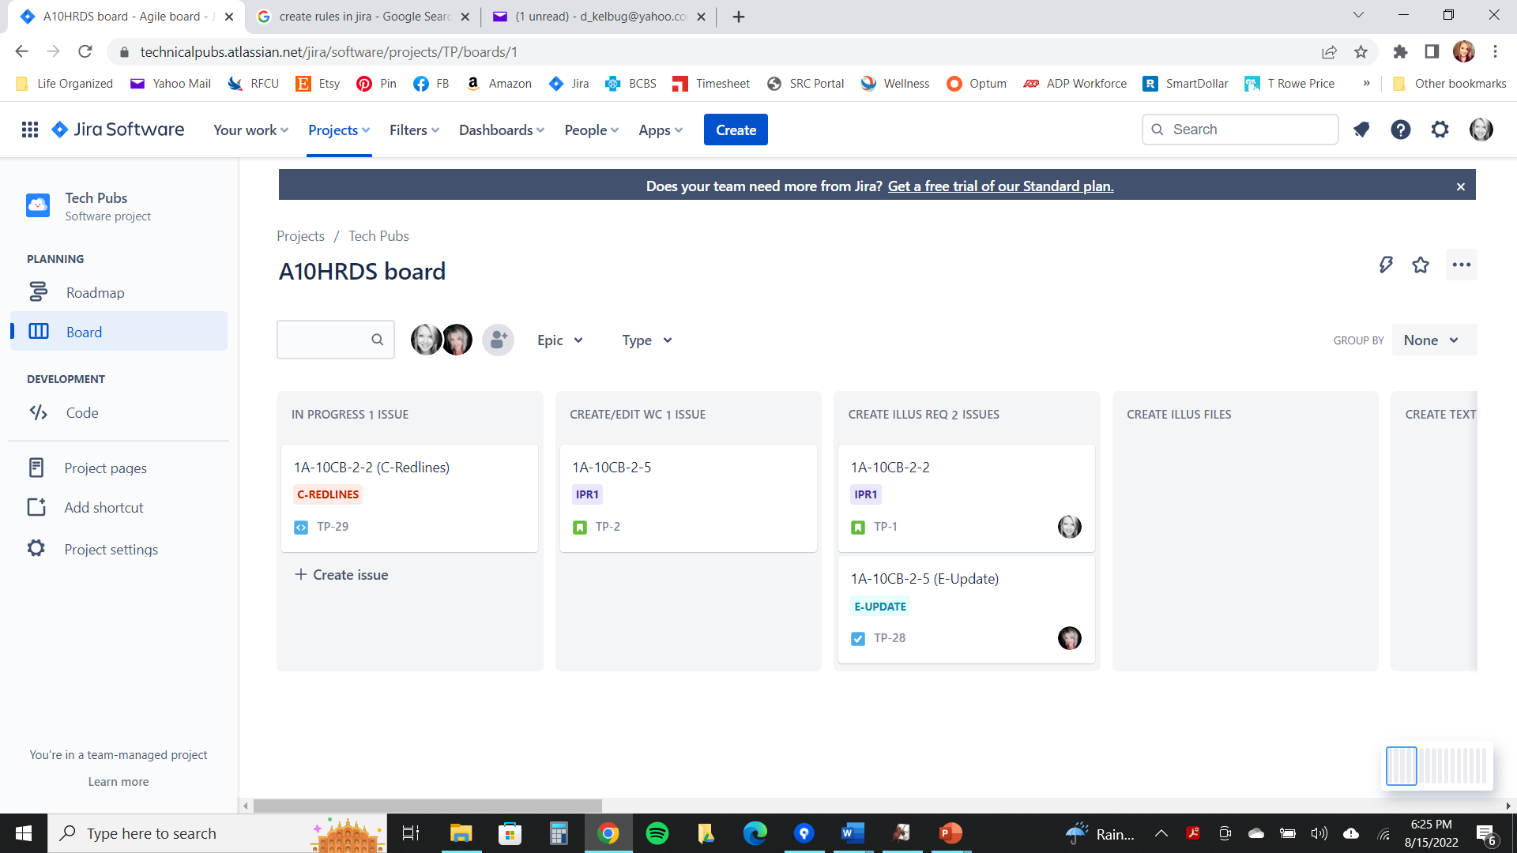

Figure : NEED PIC FROM WORK ACCOUNT Three Different Types of Epics (IPR1, C-REDLINES, E-UPDATE)



Figure : Jira Workflow (Flow of Projects, Epics, and Stories)

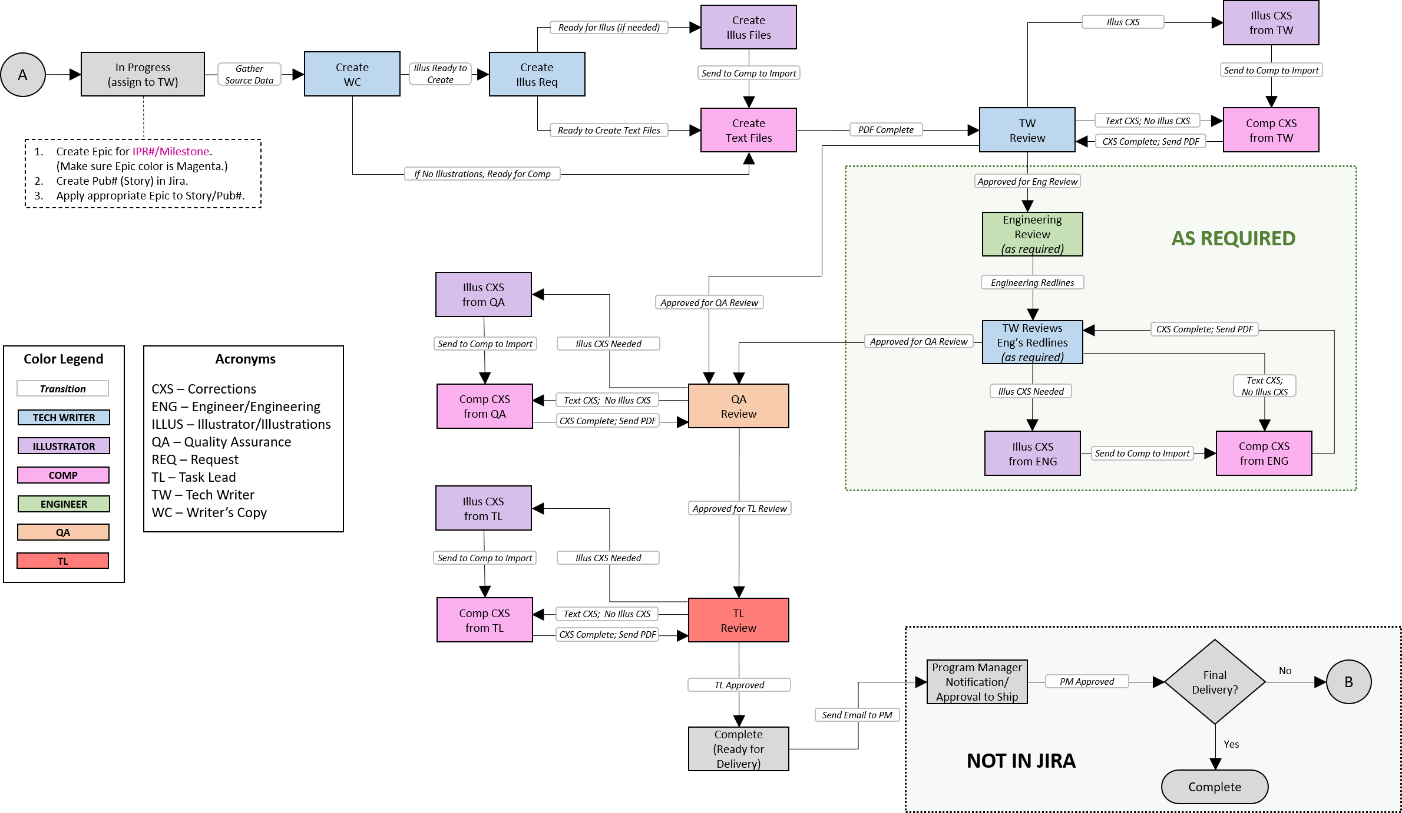

Figure : Jira Main Process Workflow

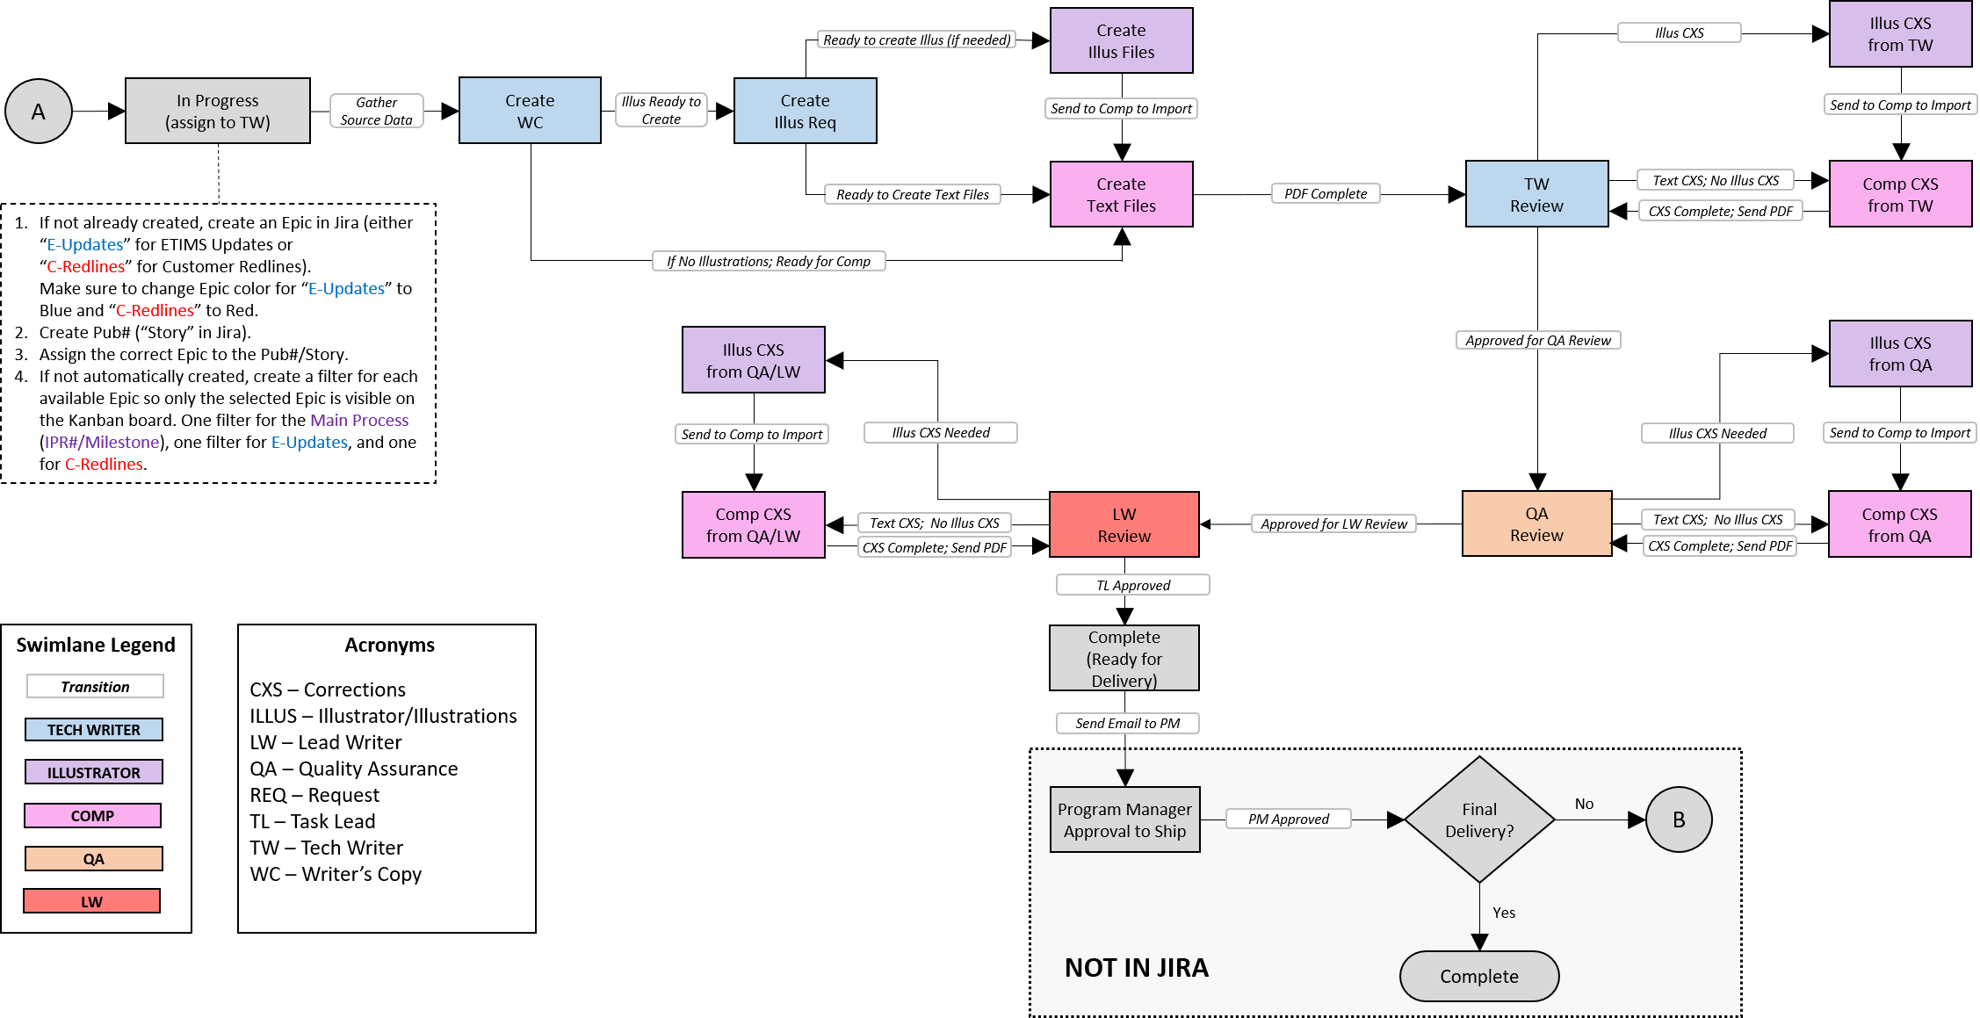

Figure : Jira ETIMS Updates Process and Customer Redlines Process Workflow

1. IMPORTANT STEPS IN JIRA
   1. How to Log in to Jira
2. Navigate to this site: [**https://tticket.scires.com/login.jsp**](https://tticket.scires.com/login.jsp)
3. Enter your **SRC Username** and **Password** (do not type “scires” before your username).
4. Select the checkbox “**Remember my login on this computer**”.
5. Click **Log In**.
6. **Tip**: Bookmark this site to your toolbar for quick access (if using Firefox, click the **Star** at the right of the menu bar ▶ Type **Jira** for Name ▶ Change location to **Bookmarks Toolbar** ▶ Click **Save**). (*Let us know if you need help bookmarking in other browsers.*)

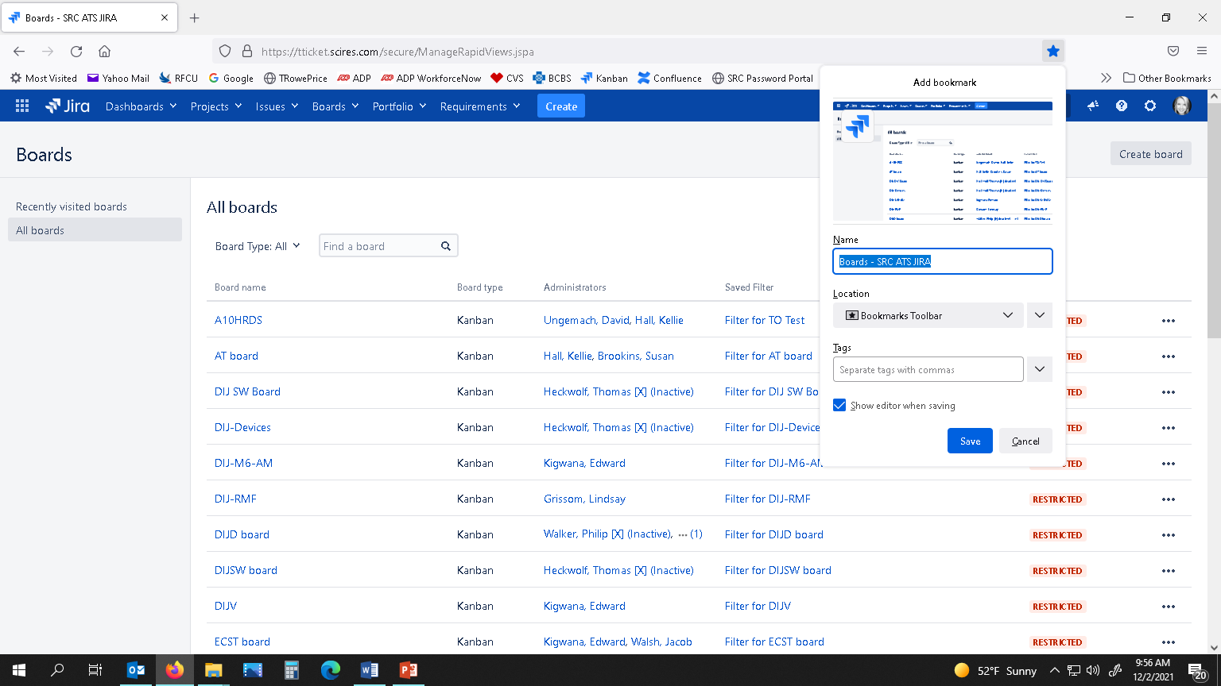

Figure : How to Create Jira Bookmark

1. After logging in, there are various screens that could load. The first step is to view the project you are working by clicking on the **Projects** button on the top menu bar, and then selecting the project name from the drop-down menu. If your Project Name is not visible, select “View All Projects” to search for it.

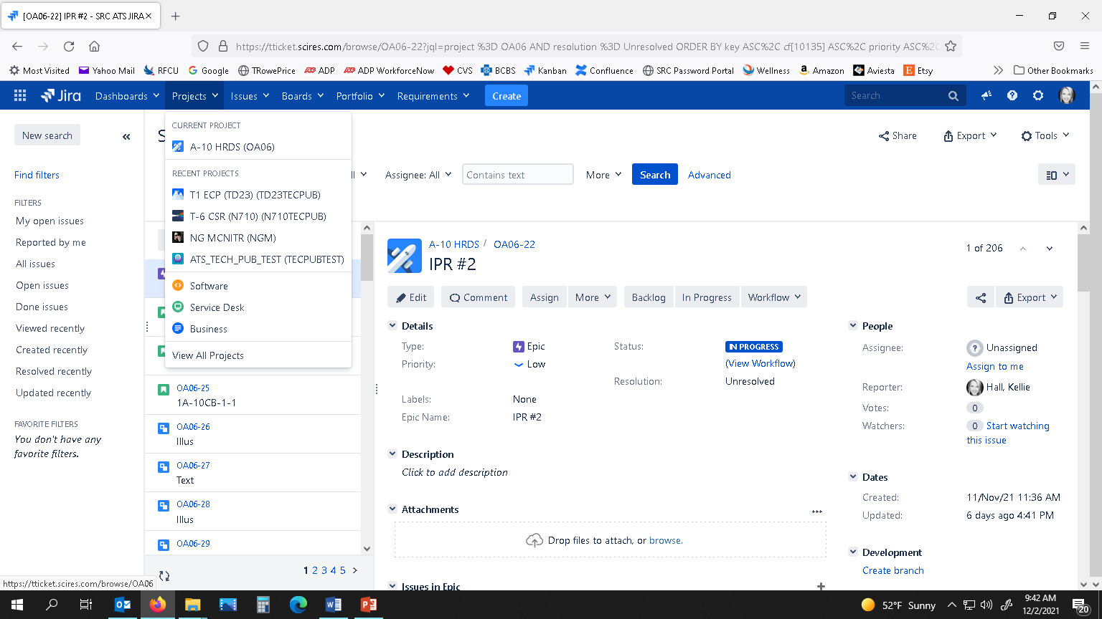

Figure : How to View Specific Project

1. Next, in the left-hand pane, click on **Kanban board**. This will be the main working area where we will be performing most of our steps.

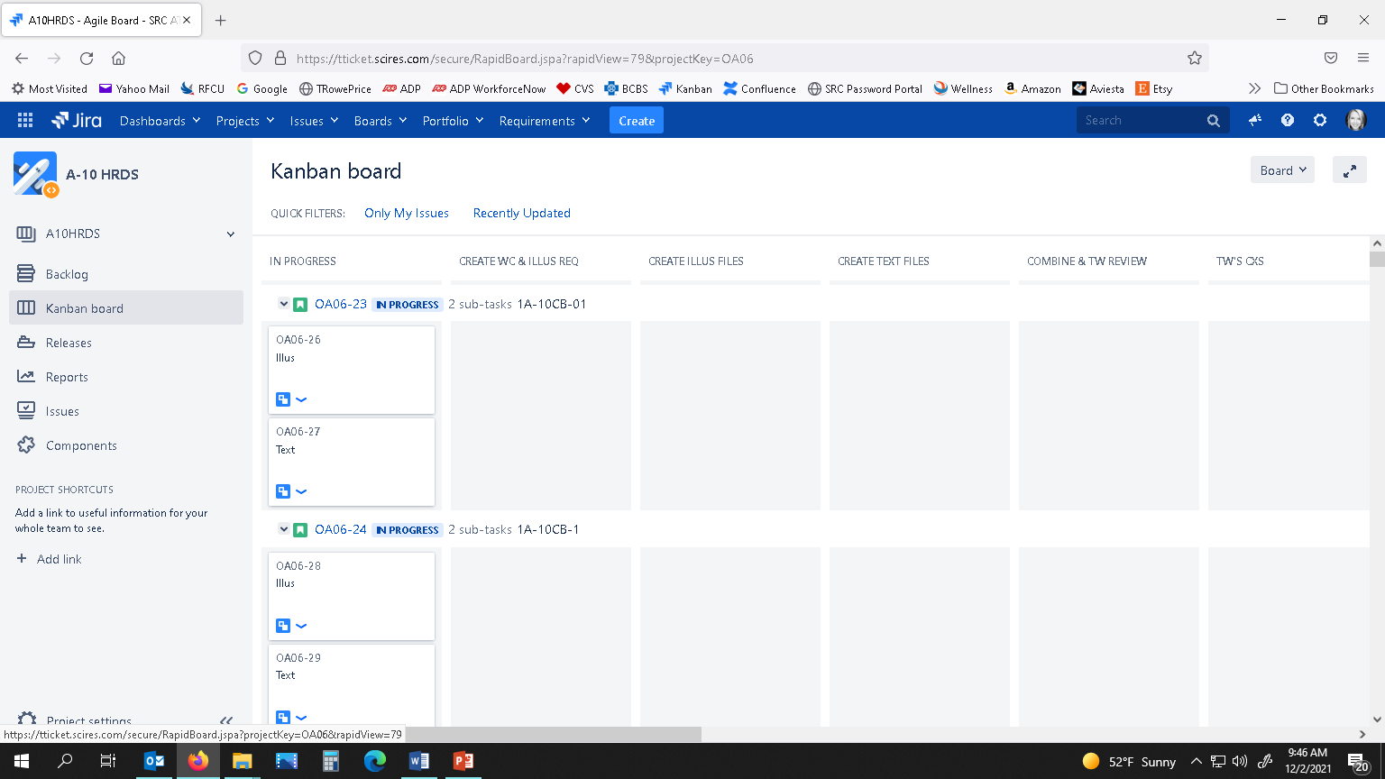

Figure : How to View Project’s Kanban Board

1. If there is more than one IPR for a project, there will be a “quick filter” at the top of the Kanban board where you can select which IPR# you want to view. For example, if there are two IPRs that have been worked, the TOs will appear twice in the Kanban board: all of the IPR #1’s TOs/Stories will appear at the top of the Kanban board, and then all of the TOs/Stories will appear again at the bottom for IPR #2. You want to make sure you click on the TO#/Story for the correct IPR, so make sure to toggle/click the correct filter at the top of the Kanban board. (Remember to always check the Jira# (e.g., N710TECPUB-54) to make sure you are modifying the correct card.) The first figure below shows the filters at the top and shows that none of them are selected (so both IPR’s TOs appear). The second figure shows where “T6 IPR #2” has been selected and only those TOs are visible.

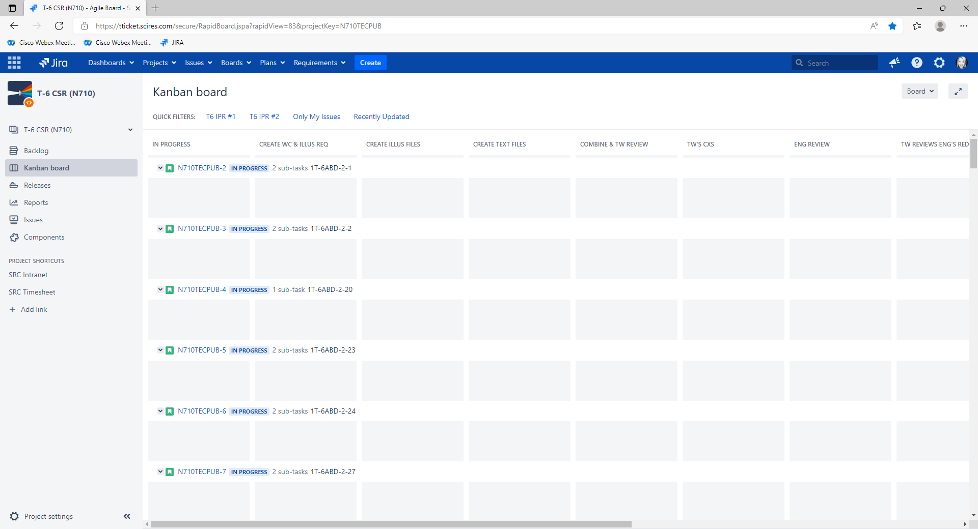

Figure : Kanban Board – No Filter Selected

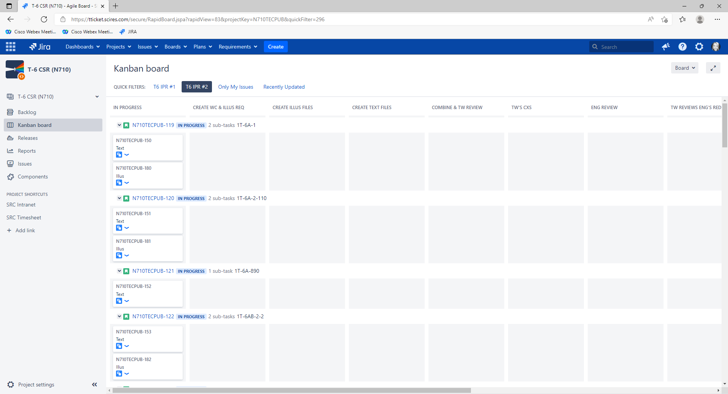

Figure : Kanban Board – IPR (Epic) Filter Applied

* 1. The Three Main Steps Performed in Jira

These are the three main actions that have to be performed in Jira when you have finished your work. **It is important to perform these steps each time you complete work and to perform them in the correct order.**

1. **Move the Sub-Task (‘Card’) to the next appropriate Swimlane.** *(According to our process workflow.)*
2. **Add an Entry to the Description section of the Subtask.** *(To keep a log of the work performed.)****<OR ADD A COMMENT AT BOTTOM OF PAGE>****.*
3. **Change the Assignee to the person that the job goes to next.** *(This will trigger an email to be sent notifying them that they have a new assignment.)*
   1. How to View Your Assignments

There are several ways to view your assigned issues:

1. On the top ribbon in Jira, click the Issues drop-down arrow and select My Open Issues. Your assigned issues will be listed on the left. Click on the individual issue for more details.

**-OR-**

1. If not already viewing the Kanban board, click Kanban board on the left pane. Next to “QUICK FILTERS:”, click the Only My Issues toggle link. This will show all issues assigned to you in a “board view” so you can see which swimlanes they reside in.

**-OR-**

1. Click the link you receive in your email when an issue has been assigned to you, and it will lead you straight to that issue’s details.

**-OR-**

1. Use the Search tool at top right of the Jira screen to search for any TO/Pub# within that project or to search for a particular issue key number (e.g., OA06-27).
2. INSTRUCTIONS FOR WRITER & TASK LEAD
   1. Create New Milestone (Epic)
3. Click the Create button at the top.
4. Change Issue Type to Epic.
5. Enter the Milestone(e.g., “IPR #1”, “E-Updates”, “C-Redlines”) in the Summary.
6. Leave Assignee as Unassigned.
7. Click CREATE.
8. Click on the Backlog link in the left-hand panel (everything is initially created in the Backlog).
9. Click on the Epic you just created.
10. Scroll to the top of the right-hand panel and click View Workflow.
11. Select the Workflow tab drop-down (at the top-middle of screen).
12. Select In Progress.
13. On the left-hand panel, click Kanban board and the Epic you just created will show up under the IN PROGRESS swimlane.
    1. Change Background Color of Epic
14. Click on Backlog.
15. Click on the Epics Panel to expand.
16. Click on 3 dots button next to the Epic you just created. Click the appropriate color for that type of epic (IPRs & other Main Processes = Magenta; E-Updates = Blue; C-Redlines = Red).
    1. Create New TO/Pub# (Story) (UPDATE FROM HERE DOWN)
17. Click Create button at the top.
18. Change Issue Type to Story.
19. Enter the TO/Pub# in Summary.
20. Change Assignee to the designated Writer.
21. Next to Epic Link, choose the associated Epic (e.g., “IPR #1”).
22. Click CREATE.
23. Click on the Backlog link in the left-hand panel (everything is initially created in the Backlog).
24. Click on the TO/Pub you just created.
25. Scroll to the top of the right-hand panel, and click View Workflow.
26. Select the In Progress tab (at the top-middle of screen).
27. On the left-hand panel, click Kanban board and the TO/Pub you just created will show up under the IN PROGRESS swimlane.
    1. Create ‘Text’ Sub-Task (UPDATE)
28. Under the IN PROGRESS swimlane, click on the TO/Pub.
29. On the right-hand panel, scroll down to Sub-Task and click Create Sub-Task.
30. For the Summary, type in “Text”.
31. Next to Issue, click the drop-down box, and select the TO/Pub that it is associated with.
32. Click Create.
33. Click on the Backlog link in the left-hand panel (everything is initially created in the Backlog).
34. Click on the Subtask you just created.
35. Scroll to the top of the right-hand panel, and click View Workflow.
36. Select the In Progress tab (at the top-middle of screen). Now the ‘Text’ Card Subtask appears on the Kanban Board under the IN PROGRESS swimlane.
    1. Create ‘Illus’ Sub-Task (UPDATE)
37. In the left-hand panel, click on Kanban Board (if not already visible).
38. Click on the TO/Pub row (this will be a row, not a ‘card’ since it now has sub-tasks).
39. Scroll down the in the right-hand panel, and next to Sub-Task, click Create Sub-Task, or if Sub-Tasks already exist, click the “**+**” to add an additional Sub-Task. A new window appears.
40. Change Summary to “Illus”.
41. Next to Issue, click the drop-down arrow, and select the appropriate TO/Pub.
42. Click Create.
43. Click on the Backlog link in the left-hand panel (everything is initially created in the Backlog).
44. Click on the Subtask you just created.
45. Scroll to the top of the right-hand panel, and click View Workflow.
46. Select the In Progress tab (at the top-middle of screen).
    1. Illus Request Ready for Illustrator
47. When the Illus Request is ready for the Illustrator, under the CREATE WC & ILLUS REQ swimlane, click and drag the ‘Illus’ Card and move to the CREATE ILLUS FILES column.
48. With the ‘Illus’ Card selected, in the right-hand pane, under Description, add a hard return under the last entry, and enter “Date – Name – Ready for Illus, Sending to (Illustrator’s Name)”.
49. Scroll up to People, change the Assignee to the person that you are sending the Illus Request to (by clicking in the drop-down box arrow and selecting the designated Illustrator), and then click the checkmark button.
50. This person will now receive an email notification that they have an issue waiting on them.
    1. Writer’s Copy Ready to Create Text Files
51. When the Writer’s Copy is ready for text pages to be created, under the CREATE WC & ILLUS REQ swimlane, scroll down to the TO/Pub row, click and drag the ‘Text’ Card and move to the CREATE TEXT FILES swimlane.
52. With the ‘Text’ Card selected, on the right-hand panel, under Description, add a hard return under the last entry, and enter “Date – Name – Ready to Create Text Files, Sending to (Writer’s Name)”.
53. Under People, change Assignee to the person that will be creating the text pages (by clicking in the drop-down box and selecting the designated Writer), and then click the checkmark button.
54. This person will now receive an email notification that they have an issue waiting on them.
    1. Text Files Complete
55. When the text portion is complete, under the CREATE TEXT FILES swimlane, click and drag the ‘Text’ Card to the COMBINE FILES & TW REVIEW swimlane.
56. In the right-hand panel under Description, add a hard return after the last entry, and type “Date – Name – Text is Complete, Holding for Illus”. Click Save.
    1. Illus Complete, Ready for Writer to Combine Files
57. In the top ribbon, select the Projects drop-down arrow, and select the correct Project.
58. In the left-hand panel (if not already selected) select Kanban Board.
59. To filter your assignments, click the “Only My Issues” toggle link at the top of the Kanban board (next to QUICK FILTERS:).
60. Look under the COMBINE FILES & TW REVIEW swimlane to see which ‘Illus’ card has been completed and ready to place into text files.
61. Once you have placed the illustration files into the text files on the W drive, combine the files into a PDF, and save in the “**TW REVIEW**” folder.
62. In Jira, click and drag the ‘Illus’ Card to the DONE swimlane. Now click on the ‘Text’ Card. In the right-hand pane, change the name of the Sub-Task from “Text” to “Combined”.
63. While the ‘Combined’ Card is still selected, in the right-hand pane, under Description, add a hard return after the last entry and type “Date – Name – Files have been combined, Ready for Writer Review”. Click Save.
64. Complete a review of the PDF. If there are corrections to send back to the Illustrator, complete the section called **TW REVIEW COMPLETE, ILLUS CORRECTIONS NEEDED**. (If there are no corrections needed, it will then be ready to send to the Engineer (if required) or to QA/LW. Follow instructions for either **COMBINED FILE READY FOR ENGINEER REVIEW** or **COMBINED FILE READY QA/LW**).
    1. TW Review Complete, Illus Corrections Needed
65. In the top ribbon, select the Projects drop-down arrow, and select the correct Project.
66. In the left-hand panel (if not already selected) select Kanban Board.
67. To filter your assignments, click the “Only My Issues” toggle link at the top of the Kanban board (next to QUICK FILTERS:).
68. Find the TO/Pub row for which you are working. Under the COMBINE FILES & TW REVIEW swimlane, click on the ‘Combined’ Card and drag to the TW’S CXS swimlane.
69. In the right-hand panel, under Description, add a hard return after the last entry, and type “Date – Name – Illus Corrections Needed, Sending to (Illustrator’s Name)”. Click Save.
70. In the right-hand panel, under People, click next to Assignee, select the drop-down arrow, select the designated Illustrator, and click the checkmark. The Illustrator will now receive a notification that they have an issue waiting for them (If you are not sure who the Illustrator is, look under the Description to see who completed an entry).
    1. TW Review Complete, Text Corrections Needed (no illus corrections)
71. In the top ribbon, select the Projects drop-down arrow, and select the correct Project.
72. In the left-hand panel (if not already selected) select Kanban Board.
73. To filter your assignments, click the “Only My Issues” toggle link at the top of the Kanban board (next to QUICK FILTERS:).
74. Find the TO/Pub row for which you are working. Under the COMBINE FILES & TW REVIEW swimlane, click on the ‘Combined’ Card and move to the TW’S CXS swimlane.
75. In the right-hand panel, under Description, add a hard return after the last entry, and type “Date – Name – Text Corrections Needed, Sending to (Writer’s Name)”. Click Save.
76. In the right-hand panel, under People, click next to Assignee, select the drop-down arrow, select the designated Writer, and click the checkmark. The Writer will now receive a notification that they have an issue waiting for them.
    1. Illus Completed TW’s Corrections, Ready for TW Review
77. In the top ribbon, select the Projects drop-down arrow, and select the correct Project.
78. In the left-hand panel (if not already selected) select Kanban Board.
79. To filter your assignments, click the “Only My Issues” toggle link at the top of the Kanban board (next to QUICK FILTERS:).
80. Look under the COMBINE FILES & TW REVIEW swimlane, and search for the ‘Combined’ Card that has been assigned to you. The Description should be similar to “Date – Illus’s Name – Illus Completed TW’s CXS – Sending to Writer (You)”.
81. Go to this TO/Pub’s folder on the server (W drive) and import the corrected illustrations into the text files. Make any needed text corrections. Re-create a PDF and perform a review. If it needs to go back to Illustrator for more corrections, follow the section called **TW REVIEW COMPLETE, ILLUS CORRECTIONS NEEDED**. If no corrections are needed, follow the instructions under **COMBINED FILE READY FOR QA/LW**. If an Engineering Review is required first, follow the instructions under **COMBINED FILE READY FOR ENGINEER REVIEW**.
    1. Combined File Ready for Engineer Review



The following instructions only occur when an Engineering Review is required (usually for the 80% IPR and Verification).

1. After the Writer approves the job (with no more corrections needed), it is now ready to send to Engineering. After recreating the combined file, select the Projects drop-down arrow in Jira, and select the correct Project.
2. In the left-hand pane (if not already selected) select Kanban Board.
3. To filter your assignments, click the “Only My Issues” toggle link at the top of the Kanban board (next to QUICK FILTERS:).
4. In the RECOMBINE & TW REVIEW swimlane, find the correct TO/Pub row, select the ‘Combined’ card and drag it to the ENG REVIEW swimlane.
5. With this card still selected, in the right-hand pane under Description, add a hard return after the last entry and type: “Date – Name – Ready for Eng Review – Sending to (Engineer’s Name)”.
6. Under People, click next to Assignee, select the drop-down arrow, select the designated Writer, and then click the checkmark.
   1. Engineer Review Complete, No Redlines
7. Save the PDF ready for QA/LW in the “**QA**” folder on the W drive using the correct naming convention.
8. In the top ribbon of Jira, select the Projects drop-down arrow, and select the correct Project.
9. In the left-hand panel (if not already selected) select Kanban Board.
10. To filter your assignments, click the “Only My Issues” toggle link at the top of the Kanban board (next to QUICK FILTERS:).
11. Find the TO/Pub row for which you are working. Under the ENG REVIEW swimlane, click and drag the ‘Combined’ Card to the QA/TL REVIEW swimlane.
12. In the right-hand panel, under Description, add a hard return after the last entry, and type “Date – Name – Eng Review Complete from (Eng’s Name), No Redlines, Ready for QA/LW”. Click Save.
13. In the right-hand panel, under People, click next to Assignee, select the drop-down arrow, select the designated QA or LW personnel, and then click the checkmark. QA or LW will now receive a notification that an issue has been assigned to them.
    1. Engineer Review Complete, Writer to Integrate Redlines
14. In the top ribbon, select the Projects drop-down arrow, and select the correct Project.
15. In the left-hand panel (if not already selected) select Kanban Board.
16. To filter your assignments, click the “Only My Issues” toggle link at the top of the Kanban board (next to QUICK FILTERS:).
17. Find the TO/Pub row for which you are working. Under the ENG REVIEW swimlane, click and drag the ‘Combined’ Card to the TW REVIEWS ENG REDLINES swimlane.
18. In the right-hand panel, under Description, add a hard return after the last entry, and enter “Date – Name – Eng Review Complete from (Eng’s Name), Integrating Redlines”. Click Save.
19. In the right-hand panel, under People, click next to Assignee, select the drop-down arrow, and make sure the designated Writer is still selected. Click the checkmark.
20. Save the Eng Redlines in the W drive under the “**TW REVIEW**” folder. Integrate the Eng’s redlines in a new PDF copy to send to Illus and/or Writer to make changes. Save in “**TW REVIEW**” folder and follow instructions for **ENGINEERING CORRECTIONS READY FOR ILLUSTRATOR.**
    1. Engineer Corrections Ready for Illustrator
21. In the top ribbon, select the Projects drop-down arrow, and select the correct Project.
22. In the left-hand panel (if not already selected) select Kanban Board.
23. To filter your assignments, click the “Only My Issues” toggle link at the top of the Kanban board (next to QUICK FILTERS:).
24. Find the TO/Pub row for which you are working. Under the ENG REVIEW swimlane, click and drag the ‘Combined’ Card to the TW REVIEWS ENG REDLINES swimlane.
25. In the right-hand panel, under Description, add a hard return under the last entry, and enter “Date – Name – Eng Review Complete from (Eng’s Name), Corrections Needed, Sending to (Illustrator’s Name). File located at: W:\TO_Share\WIP\xxxxxxxxx. File Name: xxxxxxxxxx.pdf”. Make sure to include the file location and file name so illustrator will know which file to open. Click Save.
26. In the right-hand panel, under People, click next to Assignee, select the drop-down arrow, and select the designated Illustrator. Click the checkmark.
    1. Illus Completes Engineer’s Corrections, Ready for TW to Recombine and Review
27. Once illus has finished their corrections: In Jira, select the Projects drop-down arrow, and select the correct Project.
28. In the left-hand panel (if not already selected) select Kanban Board.
29. To filter your assignments, click the “Only My Issues” toggle link at the top of the Kanban board (next to QUICK FILTERS:).
30. In the RECOMBINE & TW REVIEW swimlane, find the ‘Combined’ Card that has been assigned to you. Once you know which TO/Pub to work on, locate the PDF of the correction markups on the W drive in the “**TW REVIEW**” folder. Import the newly corrected illustration files into the text files. Re-create a PDF and perform a Writer’s Review. If any corrections are needed by the Illustrator, follow instructions for **ENG CORRECTIONS READY FOR ILLUSTRATOR**. If the file is good and no corrections are required, follow instructions for **COMBINED FILE READY FOR QA/LW**.
    1. Combined File Ready for QA/LW Review
31. When the PDF has been re-combined and the Writer finds no other corrections, it is ready to send to QA and/or LW. In Jira, select the Projects drop-down arrow, and select the correct Project.
32. In the left-hand panel (if not already selected) select Kanban Board.
33. To filter your assignments, click the “Only My Issues” toggle link at the top of the Kanban board (next to QUICK FILTERS:).
34. In the RECOMBINE & TW REVIEW swimlane, find the TO/Pub row, select the ‘Combined’ Card and drag to the QA/LW REVIEW swimlane.
35. With card still selected, in the right-hand pane, under Description, add a hard return after the last entry, and enter, “Date – Name – Ready for QA/LW Review, Sending to (Name)”.
36. Under People, click next to Assignee, select the drop-down arrow, and select the designated QA or LW. Click the checkmark.
    1. QA/LW Illus Corrections Complete, Ready for Writer to Recombine for QA/LW Review
37. Once illus has finished their corrections: In Jira, select the Projects drop-down arrow, and select the correct Project.
38. In the left-hand panel (if not already selected) select Kanban Board.
39. To filter your assignments, click the “Only My Issues” toggle link at the top of the Kanban board (next to QUICK FILTERS:).
40. In the RECOMBINE & TW REVIEW swimlane, find the ‘Combined’ Card that has been assigned to you. Once you know which TO/Pub to work on, locate the PDF of correction markups in the W drive in the “**TW REVIEW**” folder. Import the newly corrected illustration files into the text files and correct any text errors. Re-create a PDF and perform a Writer’s Review. If any corrections are needed by the Illustrator, follow the instructions for **TW REVIEW COMPLETE, ILLUS CORRECTIONS NEEDED**. Otherwise, follow the next steps.
41. In the RECOMBINE & TW REVIEW swimlane, click and drag the ‘Combined’ Card from the RECOMBINE & TW REVIEW swimlane to the QA/LW REVIEW swimlane.
42. With card still selected, in the right-hand pane, under Description, add a hard return after the last entry, and enter, “Date – Name – QA/LW Corrections Complete, Ready for QA/LW Review, Sending to (Name)”.
43. Under People, click next to Assignee, select the drop-down arrow, and select the designated QA or LW. Click the checkmark.
44. INSTRUCTIONS FOR ILLUSTRATOR
    1. Illus Request Ready to Work
45. In the top ribbon, select the Projects drop-down arrow, and select the correct Project (e.g., A-10 HRDS).

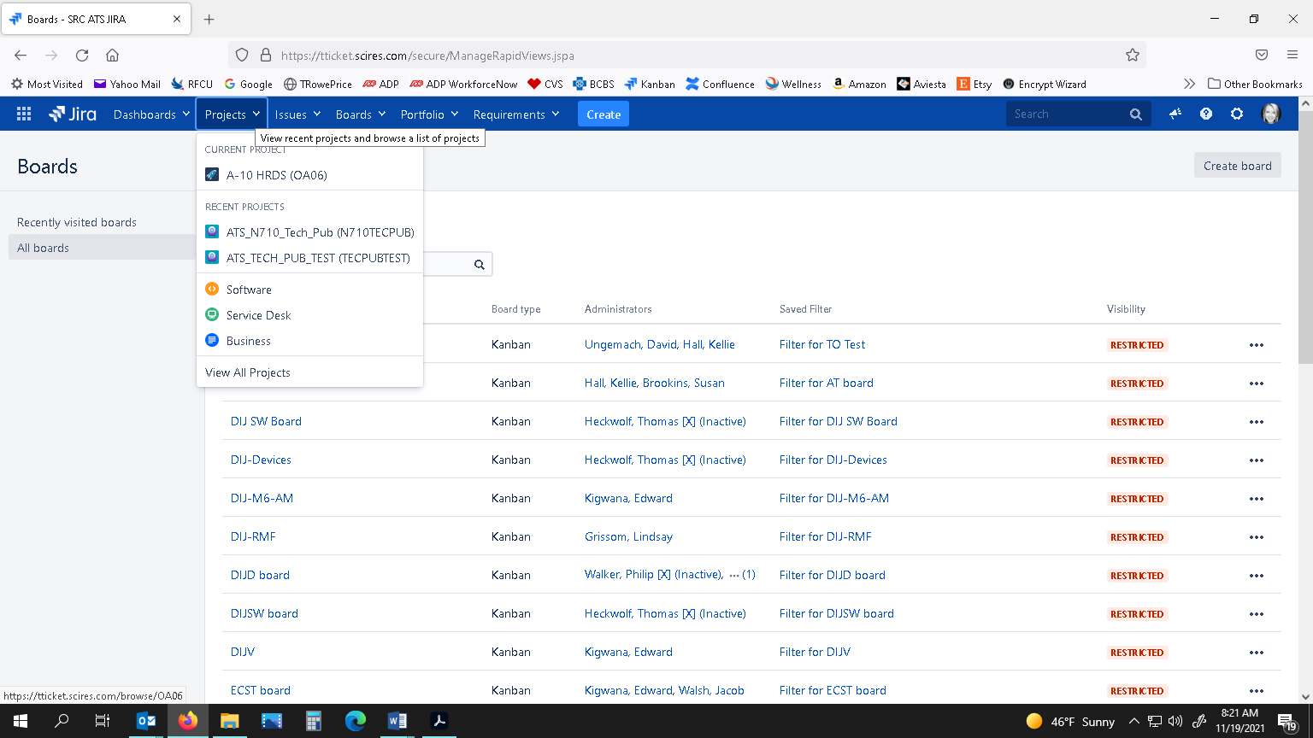

Figure : How to View Specific Project

1. In the left-hand panel (if not already selected) select Kanban Board.

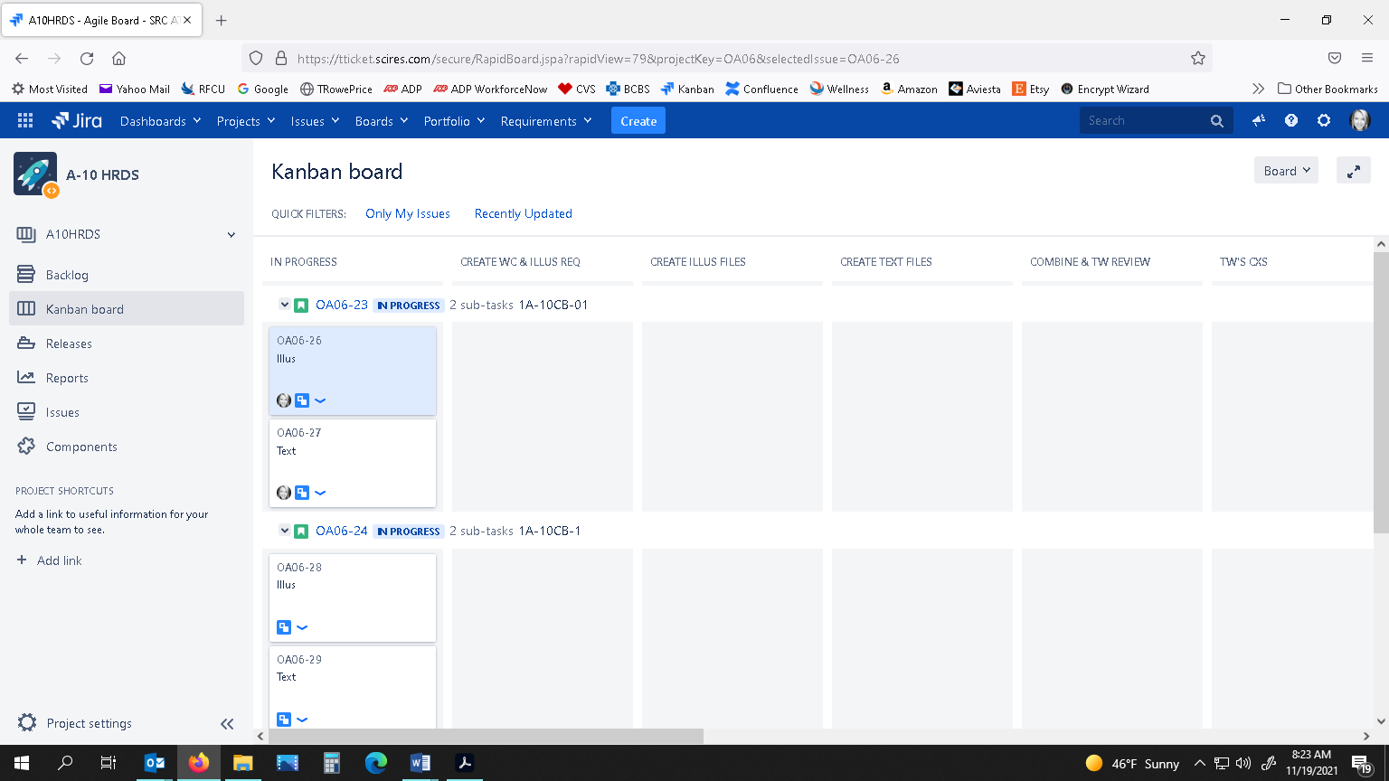

Figure : How to View Project’s Kanban Board

1. To filter your assignments, click the “Only My Issues” toggle link at the top of the Kanban board (next to QUICK FILTERS:).



Figure : How to View Only Your Assignments

1. Look under the CREATE ILLUS FILES swimlane for an ‘Illus’ Card that is ready for you to work (that has been assigned to you). If you want to see details to double-check that the illus card is assigned to you, click on the card, and details will appear in the right-hand pane. Under Description, it should read, “Date – Name – Ready for Illus, Sending to (You)”.

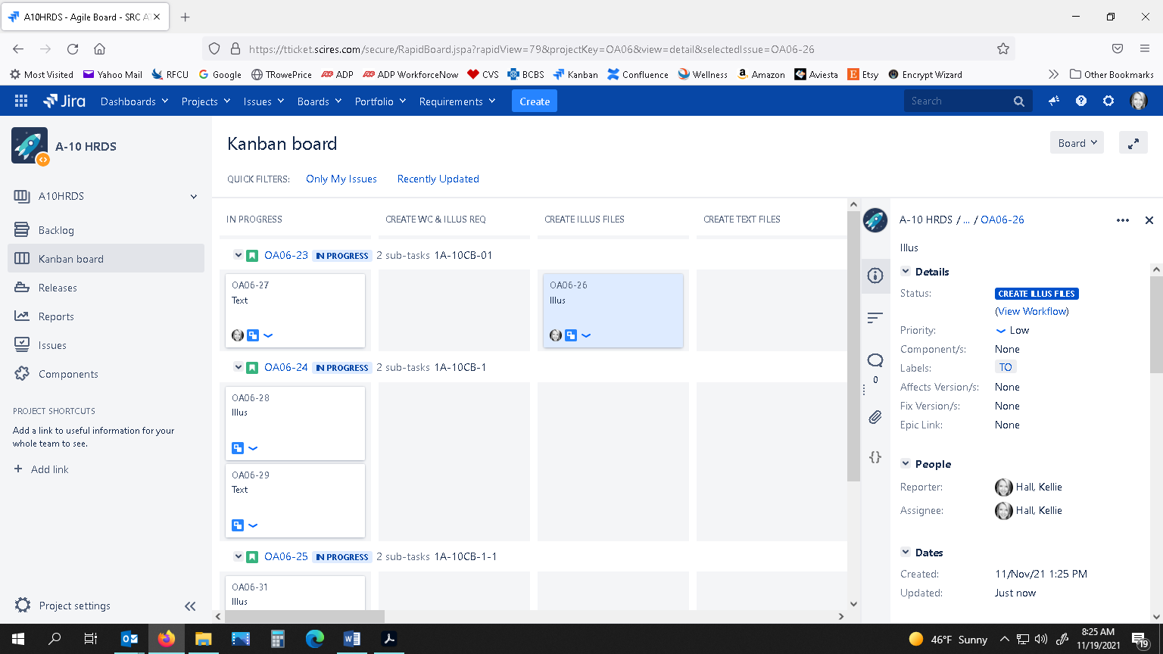

Figure : How to View Subtasks/Cards in Swimlanes

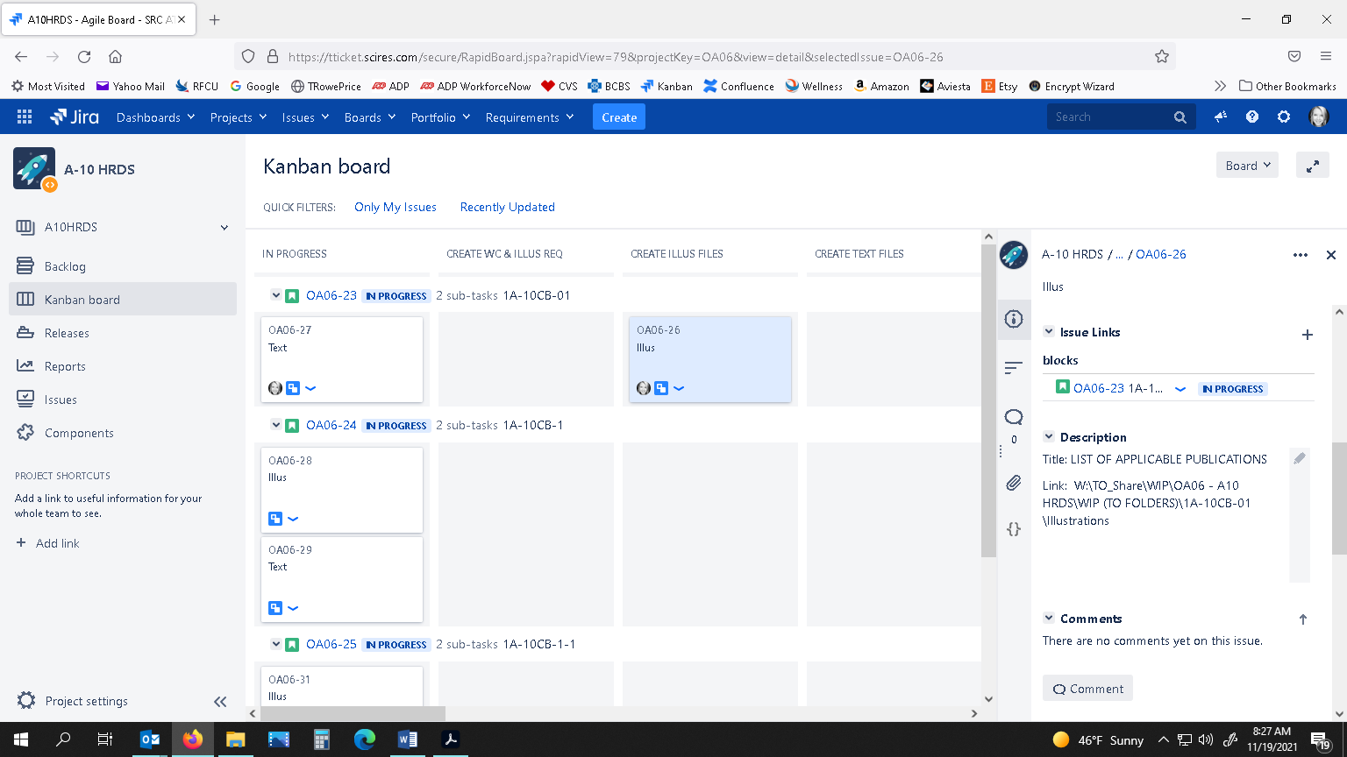

Figure : How to Fill In the Description for a Card/Subtask

1. Locate the Illus Request Form on the W drive in the ILLUS folder for the correct TO#.
2. Begin creating your Illustrations. When you have completed your work, follow the instructions for **ILLUS REQUEST FILES COMPLETE, READY FOR TW REVIEW**.
   1. Illus Request Files Complete, Ready for TW Review
3. In the top ribbon, select the Projects drop-down arrow, and select the correct Project.
4. In the left-hand panel (if not already selected) select Kanban Board.
5. To filter your assignments, click the “Only My Issues” toggle link at the top of the Kanban board (next to QUICK FILTERS:).
6. Scroll to the TO/Pub’s row. Click and drag the ‘Illus’ Card in the CREATE ILLUS FILES swimlane to the COMBINE FILES & TW REVIEW swimlane.

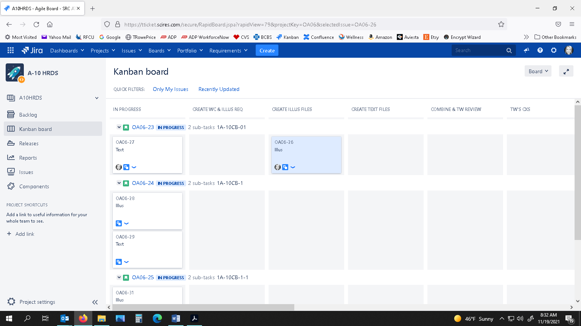

Figure : How to Drag a Subtask/Card to a Different Swimlane

1. In the right-hand panel, under Description, add a hard return after the last entry, and enter “Date – Name – Illus Request Complete, Sending to (Writer’s Name)”. Click Save.
2. While the card is still selected, in the right-hand panel, under People, click next to Assignee, select the drop-down arrow, select the designated Writer, and click the checkmark. The Writer will now receive a notification that they have an issue. (If you are not sure who the Writer is, look under the Description to see who left an entry.)

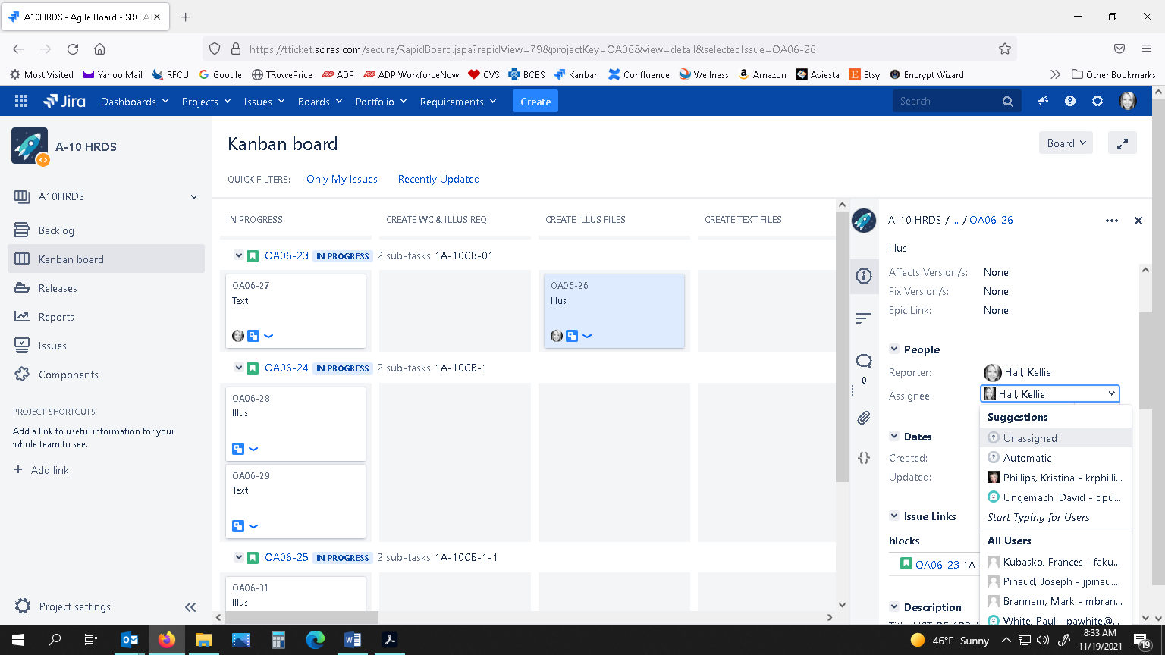 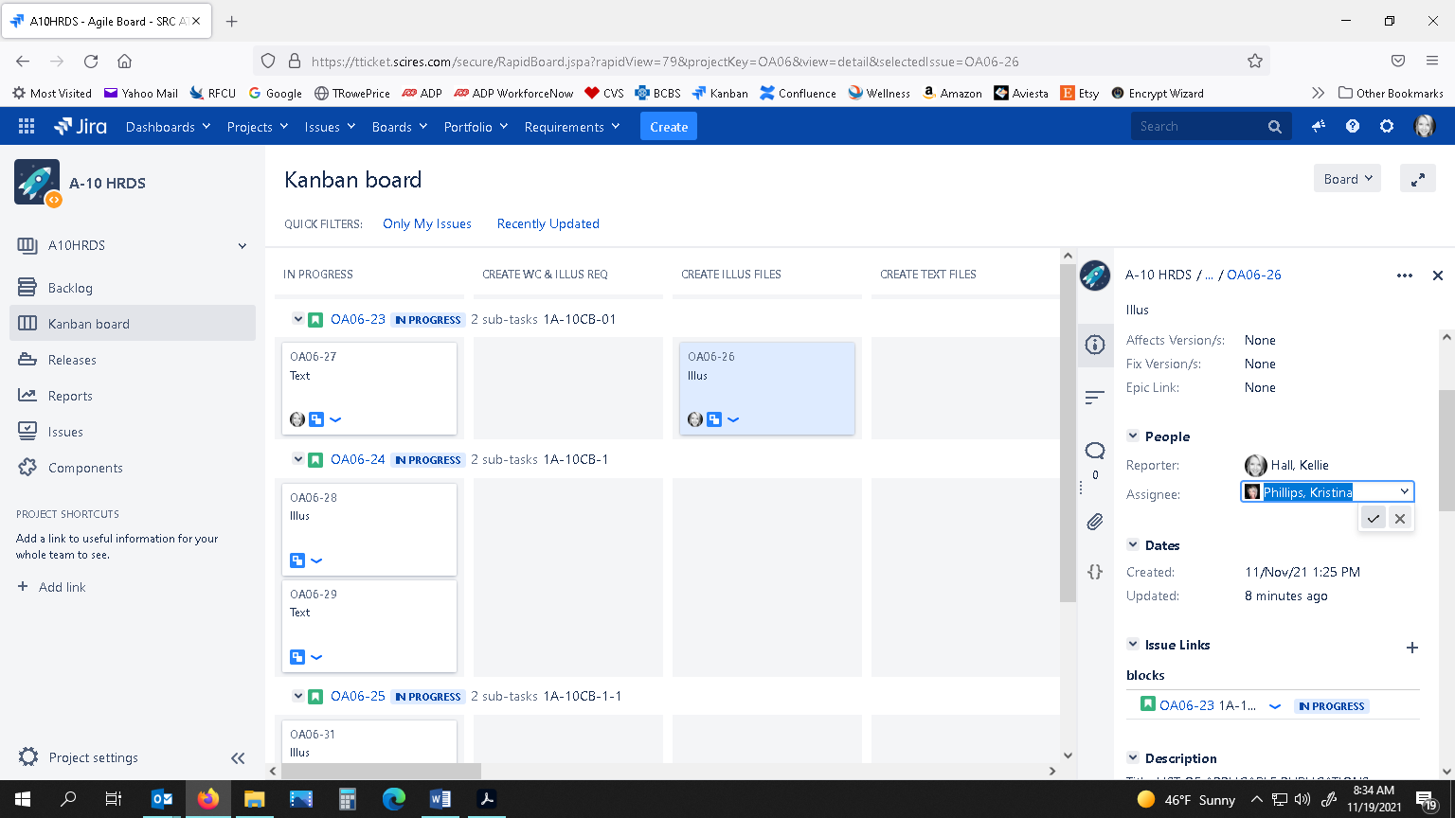

Figure : How to Change Assignee for Card/Subtask

* 1. Illustrator Completes TW’s Corrections, Ready for TW Review

1. In the top ribbon, select the Projects drop-down arrow, and select the correct Project.
2. In the left-hand panel (if not already selected) select Kanban Board.
3. To filter your assignments, click the “Only My Issues” toggle link at the top of the Kanban board (next to QUICK FILTERS:).
4. Scroll down to the TO/Pub row you were working, and then look under the TW’S CXS swimlane. Click and drag the ‘Combined’ Card (meaning illus has been combined with text) to the COMBINE FILES & TW REVIEW swimlane so the Writer will know the illustration corrections have been completed and that they need to replace them in the text files and re-create a combined PDF.

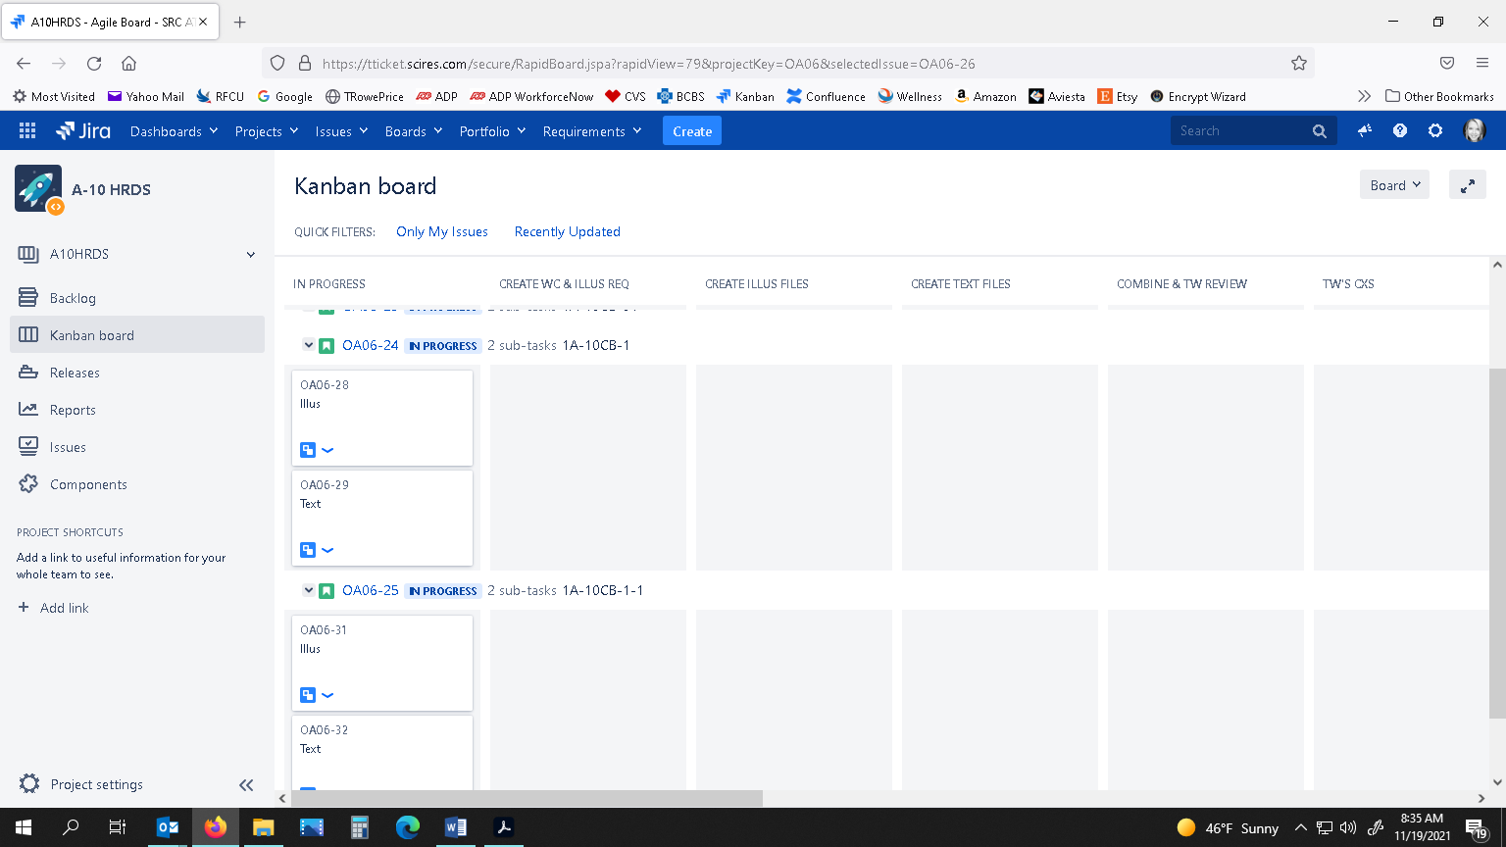

**TO/Pub#’s Row**

Figure : How to View TO/Pub# Row

1. With this card still selected, in the right-hand pane, under Description, add a hard return after the last entry, and enter “Date – Name – Illus Corrections Complete, Sending back to Writer (Writer’s Name)”. Click Save.
2. In the right-hand pane, under People, click next to Assignee, select the drop-down arrow, select the designated Writer, and click the checkmark. The Writer will now receive a notification. (If you are not sure who the Writer is, look under the Description to see who left an entry.).
   1. Illustrator Completes Engineer’s Corrections, Ready for TW to Recombine & Review
3. In the top ribbon, select the Projects drop-down arrow, and select the correct Project.
4. In the left-hand panel (if not already selected) select Kanban Board.
5. To filter your assignments, click the “Only My Issues” toggle link at the top of the Kanban board (next to QUICK FILTERS:).
6. Scroll down to the TO/Pub row you were working, and then look under the ENG’S CXS swimlane. Click and drag the ‘Combined’ Card to the RECOMBINE & TW REVIEW swimlane so the Writer will know the illustration corrections have been completed and that they need to replace them in the text files and re-create a PDF.
7. With card still selected, in the right-hand pane, under Description, add a hard return after the last entry, and enter “Date – Name – Eng Illus Corrections Complete, Sending back to Writer (Writer’s Name)”. Click Save.
8. In the right-hand pane, under People, click next to Assignee, select the drop-down arrow, select the designated Writer, and click the checkmark. The Writer will now receive a notification. (If you are not sure who the Writer is, look under the Description to see who left an entry.)
   1. QA/LW Review Complete, Ready for Illus Corrections
9. You can click on the ‘View Issue’ link in your email, **OR** go to the Kanban board and click on the “Only My Issues” link (next to QUICK FILTERS:).
10. Scroll to the right in the Kanban board and look under the swimlane QA/LW CXS.
11. Click on the correct card to view any details in the right pane under Description.
12. Perform your illus corrections, and then follow instructions for sending to the Writer to re-combine files and send back to QA/LW here: **QA/LW CXS COMPLETED BY ILLUS, READY FOR TW TO RECOMBINE FOR QA/LW REVIEW.**
    1. QA/LW Corrections Completed by Illus, Ready for TW to Recombine for QA/LW Review
13. You can click on the ‘View Issue’ link in your email, **OR**: Go to the Kanban board and click on the “Only My Issues” toggle link (next to QUICK FILTERS:).
14. Scroll down to the appropriate TO/Pub row. (TIP: or you can perform a search at the top of the screen.)
15. Click on the ‘Combined’ Card. In the right-hand pane, under Description, add a hard return under the last entry, and enter “Date – Name – QA/LW Illus Corrections Complete, Sending to Writer (Name)”. Click Save.
16. Under People, click next to Assignee, select drop-down arrow, select the Designated Writer, and click the checkmark button. The Writer will now receive a notification and they will correct any text corrections, insert illus corrections, and re-create a Combined File to send back to QA/LW.
17. INSTRUCTIONS FOR QA/LW
    1. Combined File Ready for QA/LW Review
18. You can click on the ‘View Issue’ link in your email to bring up the issue, **OR** in the top ribbon, select the Projects drop-down arrow, and select the correct Project.



Figure : How to Select Correct Project

1. In the left-hand pane (if not already selected) select Kanban board.



Figure : How to View a Project’s Kanban Board

1. To filter your assignments, click the “Only My Issues” toggle link at the top of the Kanban board (next to QUICK FILTERS:).



Figure : How to View Only Your Issues

1. Look under the QA/LW REVIEW swimlane to see what is ready for you. Find this file on the server (WR_Projects drive) in the “**QA REVIEW**” folder and perform the QA review. Use the naming conventions provided at the end of these instructions and save your redlined copy. Follow instructions below named **COMBINED FILE NEEDS QA/LW ILLUS AND/OR TEXT CORRECTIONS** if corrections are needed, or follow instructions for **QA/LW REVIEW APPROVED (no corrections)** if no corrections are needed.

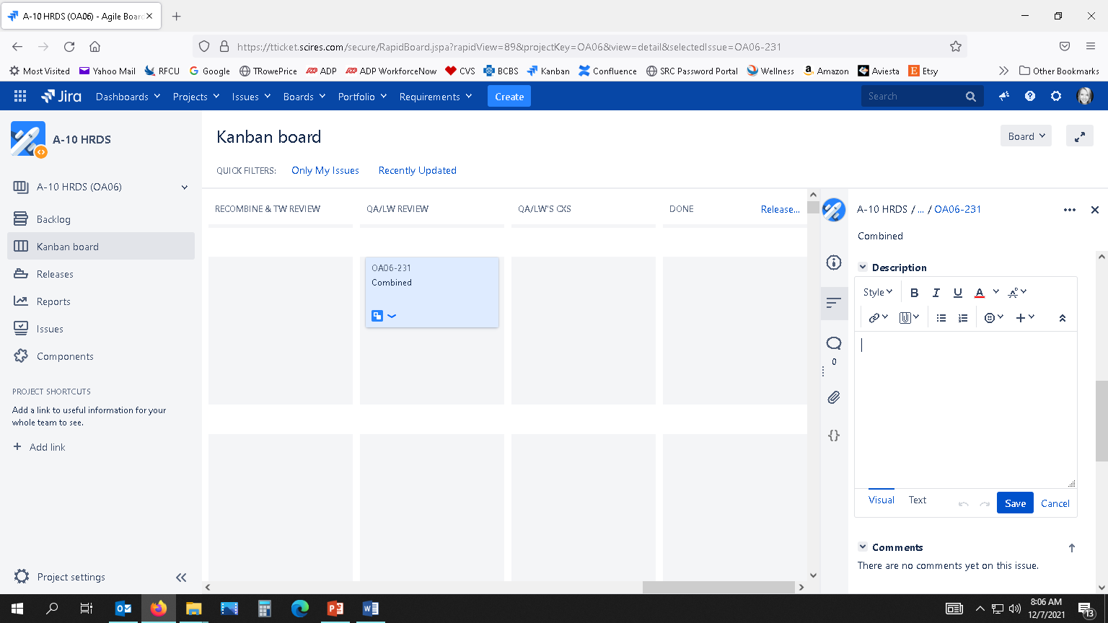

Figure : How to View Subtask/Card Under Certain Swimlane

* 1. Combined File Needs QA/LW Illus and/or Text Corrections

1. In Jira, go to the correct Kanban board under the correct project. Click “Only My Issues” toggle link at the top of the Kanban board to filter just your assignments. Scroll down to the correct TO/Pub row, then look under the QA/LW REVIEW swimlane.
2. Click and drag the ‘Combined’ Card from the QA/LW REVIEW swimlane to the QA/LW’s CXS swimlane.



Figure : How to Drag & Drop Card from Swimlane to Swimlane

1. While the card is still selected, in the right-hand pane, under Description, add a hard return after the last entry and enter, “Date – Name – QA Corrections Needed, Sending to (Illustrator’s Name)”. Click Save.   
   If no illus corrections are needed, but text corrections are needed, enter “Date – Name – QA Corrections Needed (text only), Sending to (Writer’s Name)”. Click Save.



Figure : How to Add an Entry to the Description for Subtask/Card

1. Scroll up to People, and next to Assignee, click the drop-down arrow and select the designated Illustrator and then click the checkmark. You can see who the illustrator is by viewing who typed an entry under the Description section. The illustrator will now receive a notification email. (If no illus corrections are needed, but text corrections are, change Assignee to the Writer, and then the Writer will receive a notification email.)

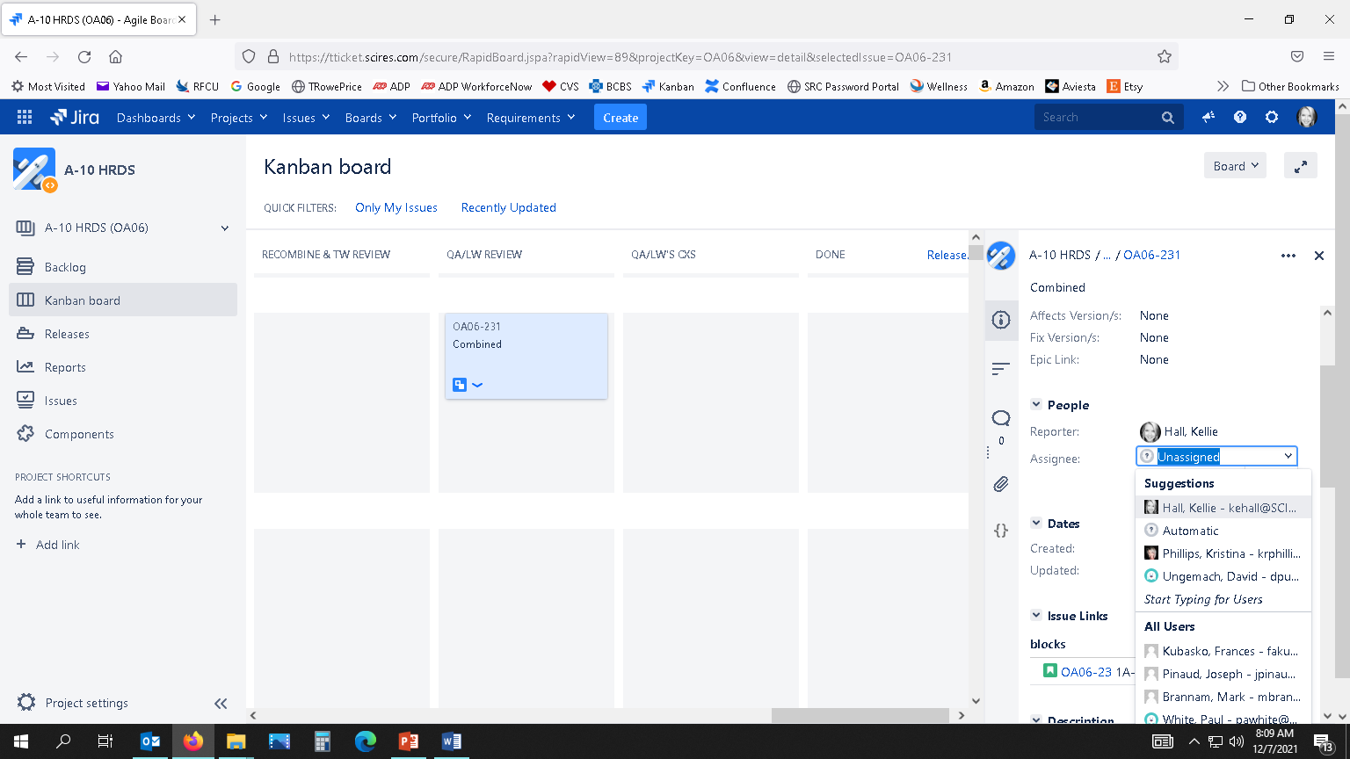

Figure : How to Change Assignee for a Subtask/Card

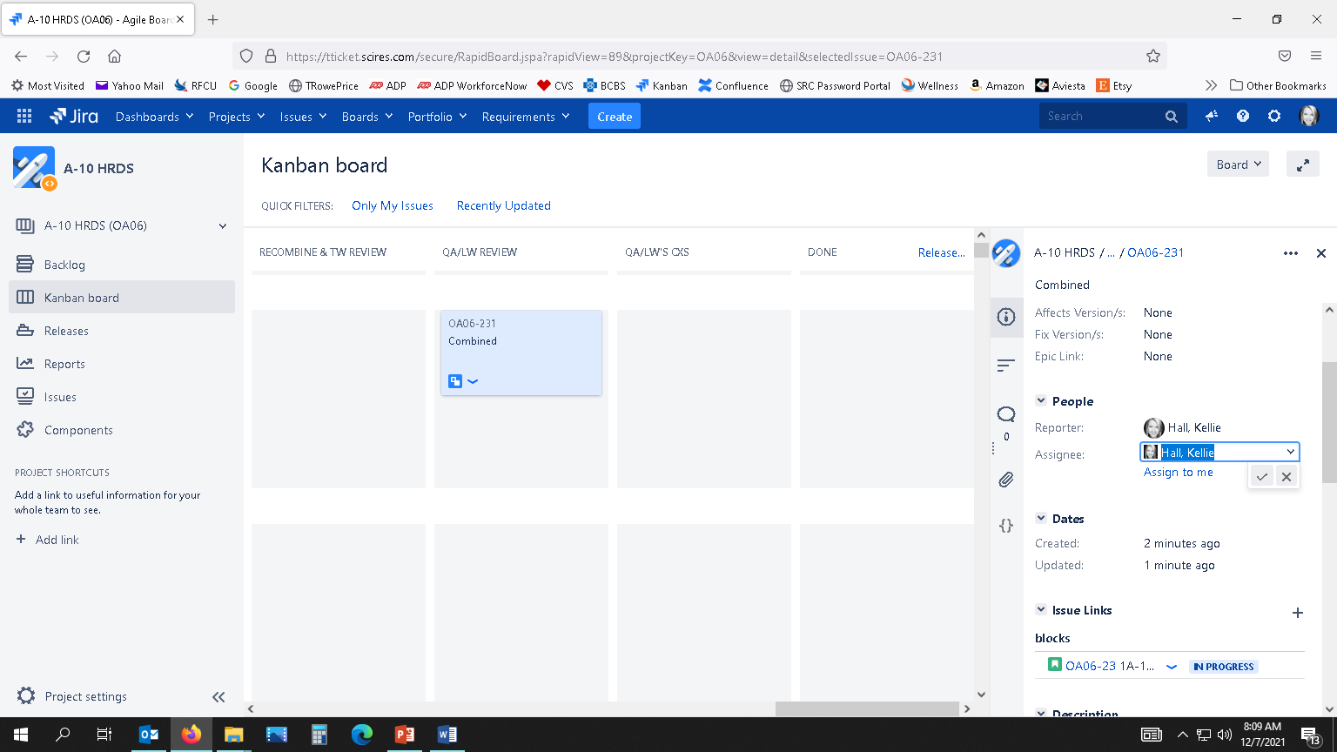

Figure : How to Accept the Selected Assignee for a Subtask/Card

* 1. QA/LW Review Approved (no corrections)

1. In Jira, go to the Kanban board under the correct project. Click “Only My Issues” toggle link at the top of the Kanban board. Scroll down to the correct TO/Pub row, then look under the QA/LW REVIEW swimlane.
2. Click on the ‘Combined’ Card in the QA/LW REVIEW swimlane. In the right-hand pane, under Description, add a hard return after the last entry and enter, “Date – Name – QA Approved”. Click Save.
3. Scroll up to People, then next to Assignee, click the drop-down arrow, select the designated Writer, and click the checkmark. You can see who the Writer is by viewing who typed an entry under the Description section. The writer will now get a notification email.
4. On the Kanban board, click and drag the ‘Combined’ Card from the QA/LW REVIEW swimlane to the DONE swimlane. A dialog box will appear asking if the entire Story (TO/Pub) is ready to move to the DONE swimlane. Click Yes.
5. TROUBLESHOOTING
   1. Accidently Moved Subtask/Card to Wrong Swimlane

If you accidently click and drag a subtask/card into the wrong swimlane and need to move it back to a previous swimlane, but Jira won’t allow you to due to how our process is set up, the following steps show how to perform a workaround (you basically move it to the first swimlane and then move it though the process until you get back to where you were):

1. Click and drag the card to the first swimlane (IN PROGRESS).
2. From there, move it through the process until you get to the swimlane you were originally on (for instance, click and drag it to the CREATE W/C AND ILLUS REQ swimlane). Then, click and drag it to the CREATE ILLUS FILES swimlane. If that is where it last was, then click and drag it to the correct swimlane that you intended to move it. Now it is ready for you to fill in the Description entry and change Assignee.
3. FILE NAMING CONVENTIONS (for Writers and QA)

*File Naming Convention:* XX_TO/PUB# - Description of File - Date.pdf

*File Naming Example:* **01_1A-10C-2-15JG2-2-1A - Ready for TW Review - 20210714.pdf**

Incremental Number TO Number Description/Process Completed Date

------------------------------------------------------------------------------------------------------------------------------------------------

* 1. Writers



* The following files are to be saved in the new “**TW REVIEW**” folder for each TO/Pubon the WR_Projects (W) Drive.
* If more corrections are needed, continue numbering the files in sequential order with the same appropriate naming conventions.

|  |  |
| --- | --- |
| **WHEN INITIAL COMBINED FILE (Text & Illus) IS READY FOR TECH WRITER REVIEW** When naming the Combined File for Writer Review, the file should be named: | |
| *Example:* | **01**_1A-10C-2-15JG-2-2 - **Ready for TW Review** - 20210714.pdf |
| **IF CORRECTIONS ARE NEEDED FROM WRITER REVIEW** When naming the Writer’s Marked-up PDF, the file should be named: | |
| *Example:* | **02**_1A-10C-2-15JG-2-2 - **TW Review’s CXS** - 20210714.pdf |
| **WHEN CORRECTED COMBINED FILE (Text & Illus) IS READY FOR TECH WRITER REVIEW AGAIN** When naming the Combined File for Writer Review after corrections have been completed, the file should be named: | |
| *Example:* | **03**_1A-10C-2-15JG-2-2 - **TW CXS Done** **Ready for TW Review** - 20210714.pdf |
| **WHEN COMBINED FILE IS READY FOR ENG REVIEW** When theWriter inserts illus into Text Files & Creates a PDF to send to Engineering, the PDF should be named: | |
| *Example:* | **05**_1A-10C-2-15JG-2-2 - **Ready for Eng Review** - 20210714.pdf |
| **INTEGRATED ENGINEERING REDLINED COPY** When theWriter integrates the Engineering Redlines, before sending PDF to get corrections, the PDF should be named: | |
| *Example:* | **06**_1A-10C-2-15JG-2-2 - **Eng Review’s CXS** - 20210714.pdf |
| **WHEN COMBINED FILE IS READY FOR WRITER REVIEW** When naming the Combined File for Writer Review after corrections have been completed, the file should be named: | |
| *Example:* | **07**_1A-10C-2-15JG-2-2 - **Eng CXS Done** **Ready for TW Review** - 20210714.pdf |
| **IF CORRECTIONS ARE NEEDED FROM WRITER REVIEW** When naming the Corrections the Writer found of the Combined File, the PDF should be named: | |
| *Example:* | **08**_1A-10C-2-15JG-2-2 - **TW Review’s CXS** - 20210714.pdf |
| **WHEN CORRECTIONS ARE COMPLETED AND TW APPROVES** When theWriter Approves Corrections, the file should be named: | |
| *Example:* | **09**_1A-10C-2-15JG-2-2 - **Ready for QA** - 20210714.pdf |

* 1. QA Personnel



* The following files are to be saved in the “**QA**” folder for each TO/Pubon the WR_Projects (W) Drive.
* If more corrections are needed, continue numbering the files in sequential order with the same appropriate naming conventions.

|  |  |
| --- | --- |
| **WHEN COMBINED FILE IS READY FOR QA** When naming the Combined File for QA, the file should be named: | |
| *Example:* | **01**_1A-10C-2-15JG-2-2 - **Ready for QA** - 20210714.pdf |
| **IF CORRECTIONS ARE NEEDED FROM QA** When naming the QA Correction Markups, the file should be named: | |
| *Example:* | **02**_1A-10C-2-15JG-2-2 - **QA’s CXS** - 20210714.pdf |
| **WHEN QA CORRECTIONS ARE COMPLETED** When naming the Combined File for QA Corrections, the file should be named: | |
| *Example:* | **03**_1A-10C-2-15JG-2-2 - **QA CXS Done** **Ready for QA** - 20210714.pdf |
| **WHEN QA CORRECTIONS ARE COMPLETED, MORE MARKUPS FOUND** When naming the QA Correction Markups again, the file should be named: | |
| *Example:* | **04**_1A-10C-2-15JG-2-2 - **QA’s CXS** - 20210714.pdf |
| **WHEN QA APPROVES CORRECTIONS** When naming the QA Approved PDF, the file should be named: | |
| *Example:* | **05**_1A-10C-2-15JG-2-2 - **QA Approved** - 20210714.pdf |